SQL 2017 Installation

SQL 2017 base installation steps are defined in this document.

1. Start SQL Server 2017 Setup

Select Installation

1. Under the ‘Installation’ menu, select New SQL Server stand-alone installation or add features to an existing installation

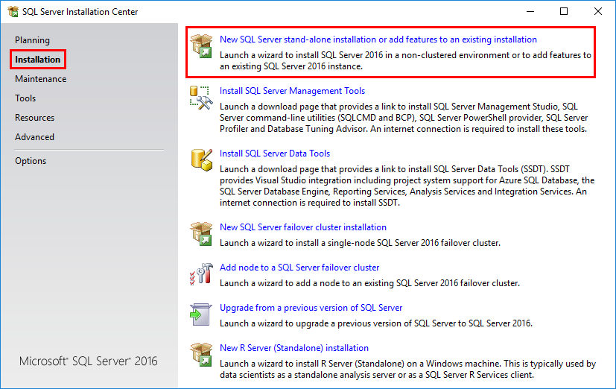

1. Product Key should populate itself 🡪 Click Next
2. Accept the license terms 🡪 Click Next
3. Install Rules will run. Select next after completion.

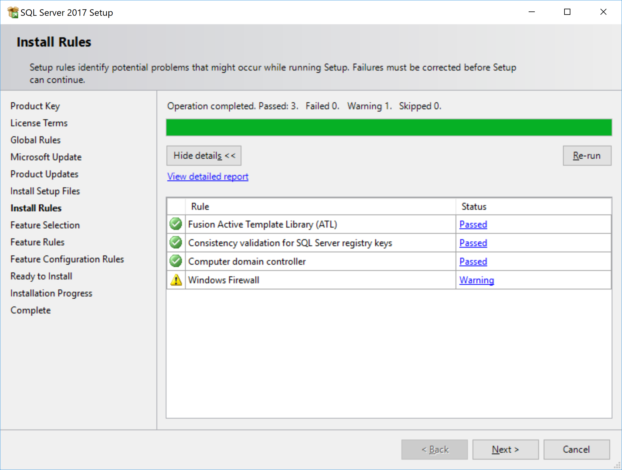

1. Rules will be installed 🡪 Click Next
2. Select the Feature as shown below 🡪 Click Next
   1. Note: If you do not want a local instance/server, do not select ‘Database Engine Services’.
      1. SQL Server Replication is only needed if databases being created are participating in Global Workshare

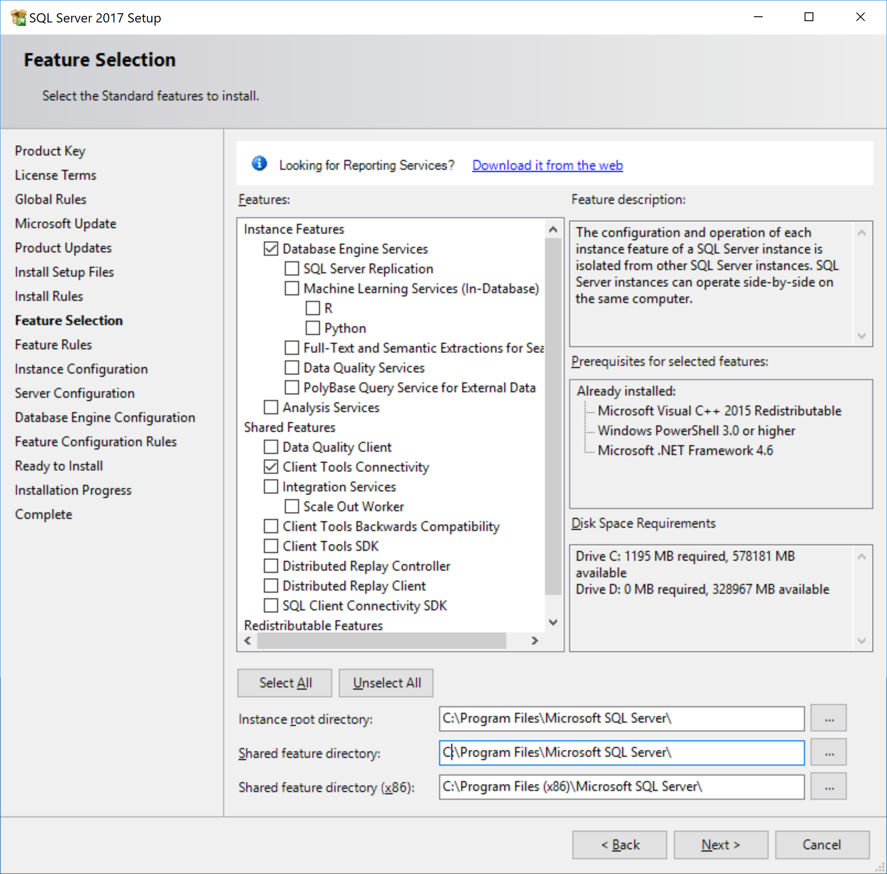

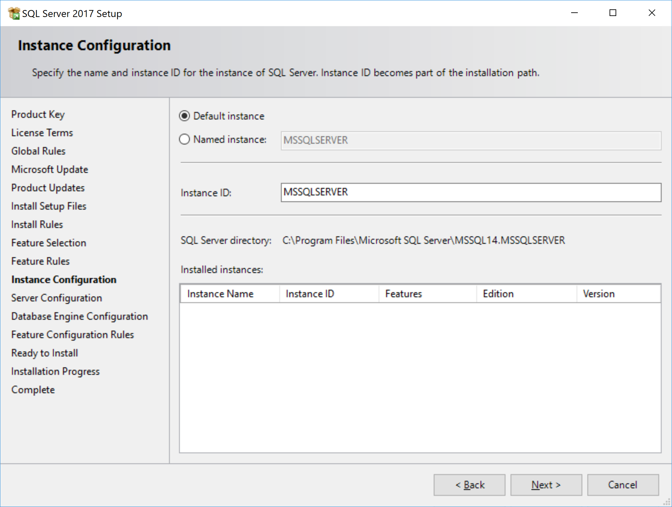

1. For Server Configuration, accept the default 🡪 Click Next

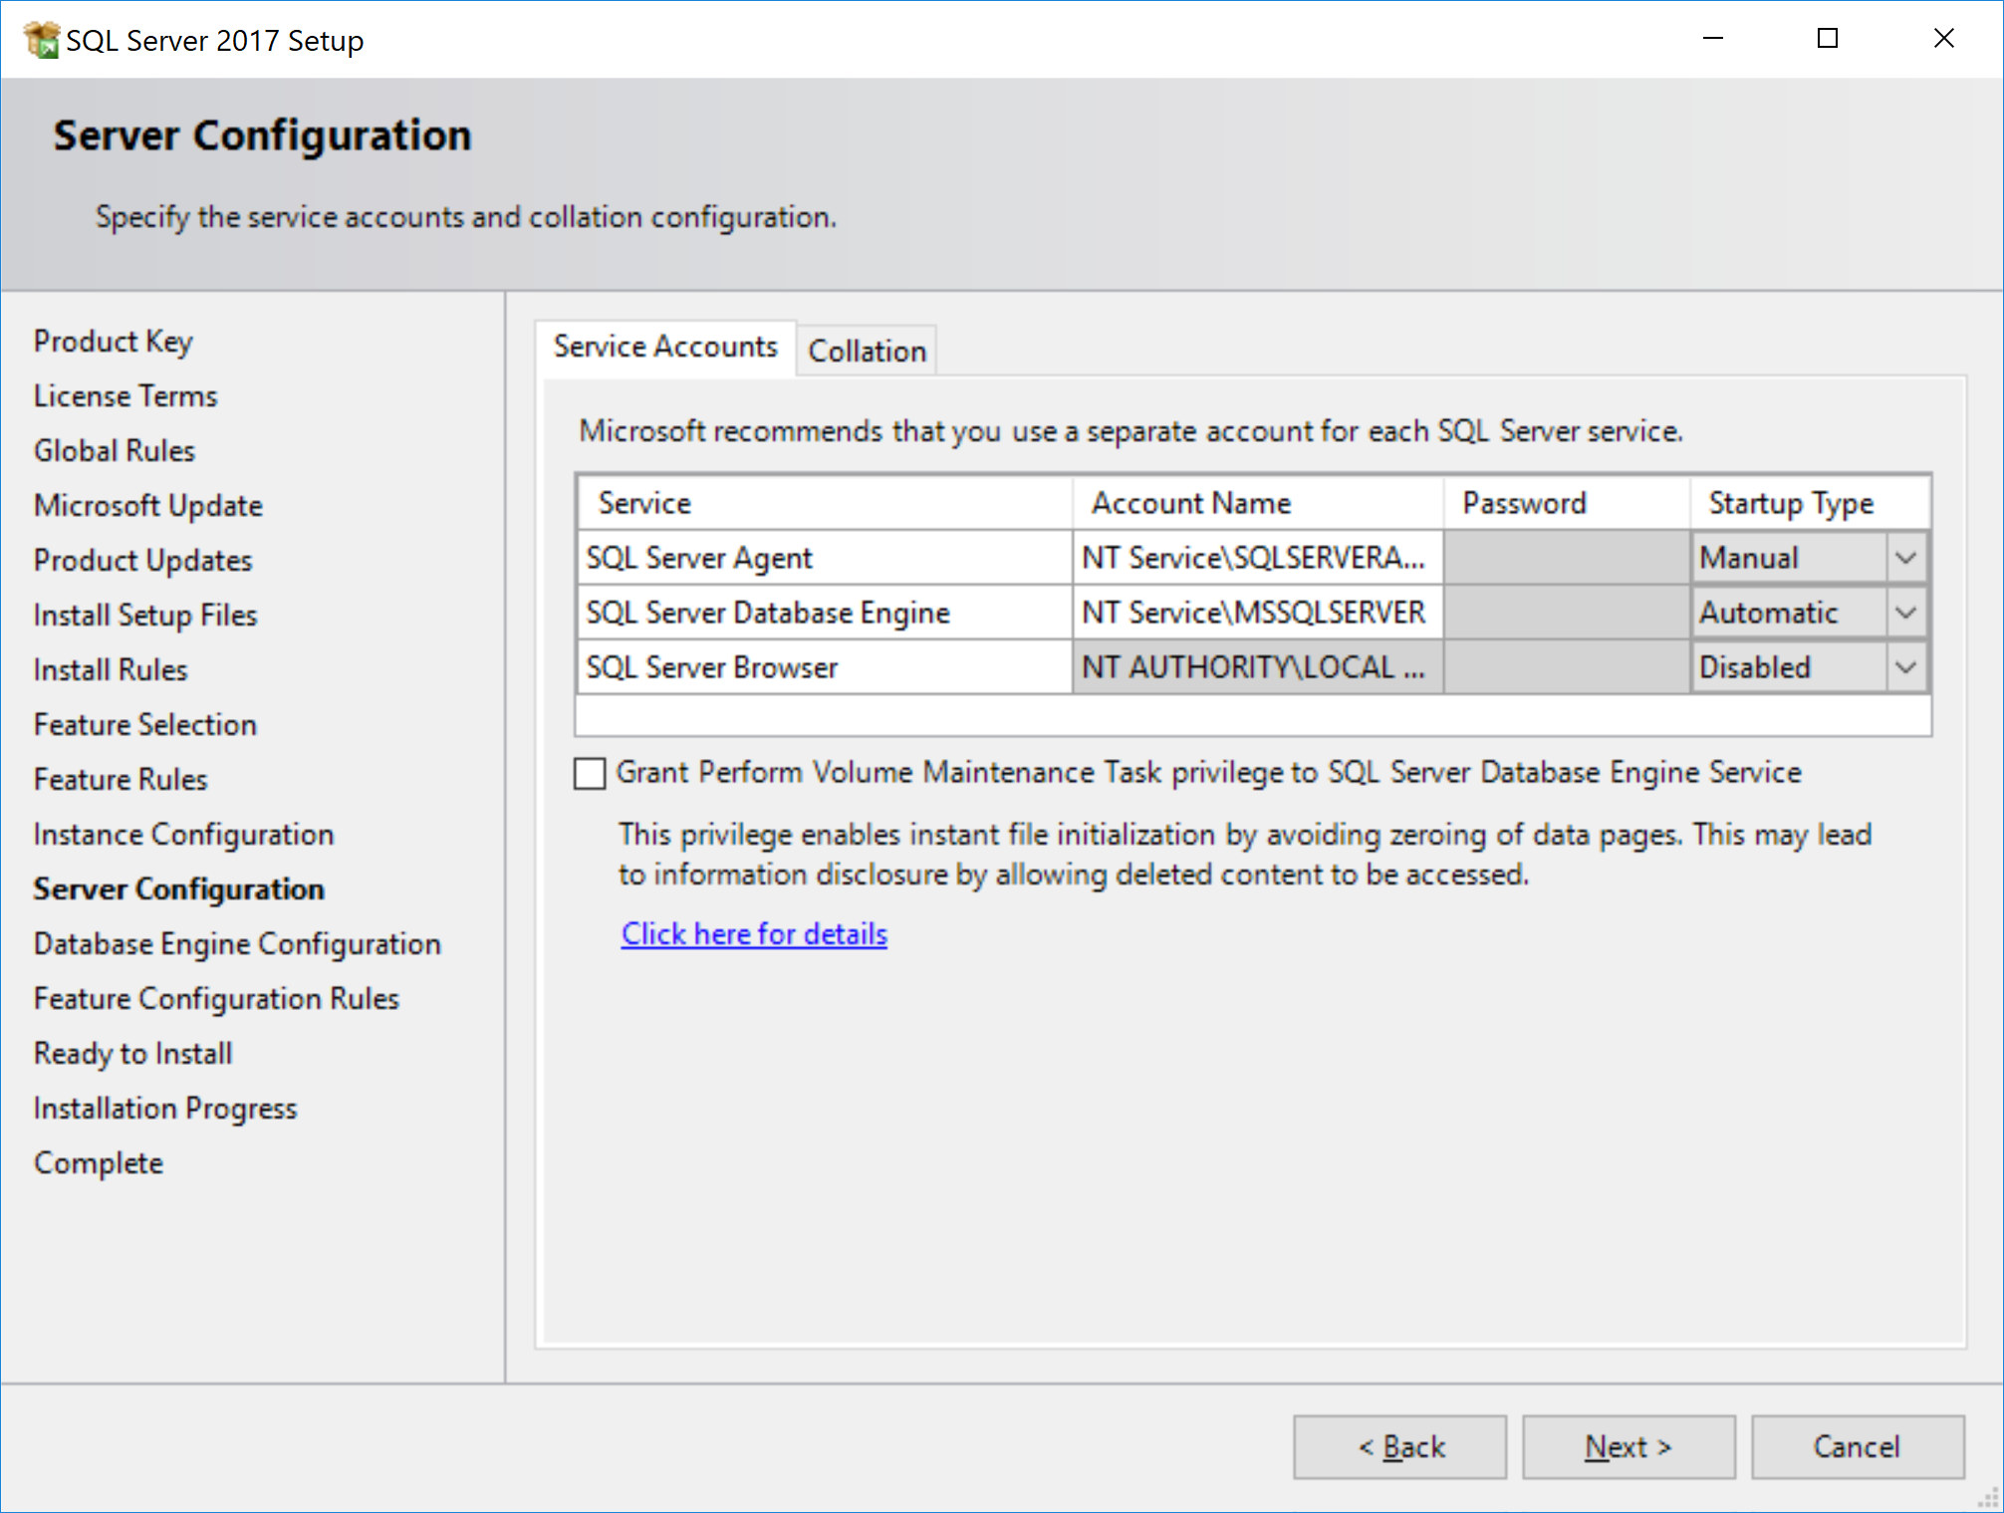

1. Under the ‘Server Configuration’ tab, Select Mixed Mode.
   1. For SQL Server administrator: Add groups/users who should have admin rights as needed
2. **OPTIONAL:** Under the ‘Data Directories’ tab, you will change the location of the ‘User database directory’ and the ‘User database log directory’. Create a “SQLData” and “SQLLogs” folder in a location of your choosing. The example places them under the location of the ‘Data root directory’.
3. **OPTIONAL:** Under the ‘TempDB’ tab, you will change the location of the ‘log directory’ and the ‘User database log directory’.
4. Ready to Install. Verify all names, file locations, and admins 🡪 Click Install
5. After Completion a message will appear for you to restart computer 🡪 Click OK
6. Click Close and then restart computer

**Installing SQL Server Management Tools**

1. Under the ‘Installation’ menu, select Install SQL Server Management Tools and it will take you to a Microsoft webpage
2. Click “Download SQL Server Management Studio” and click Run
3. After it has downloaded and the Dialog box appears, Click Install

